FULL STACK DEVELOPMENT

WITH MERN PROJECT DOCUMENTATION

**INTRODUCTION**

Project Title :: **Freelance Finder :: Discovering Opportunities, Unlocking Potential**

Teamid: LTVIP2025TMID55881

TeamMembers:

1. Team Leader:

VUYYURU UDAY PRAKASH– Full Stack Developer & Project Coordinator

Responsible for overall planning, coordination, GitHub management, and integration of frontend and backend.

2. Team Member:

VEERLAVIVEK V– Frontend Developer

Works on the React-based UI, handles component design, page routing, and user interactions.

3. Team Member:

VELUTHURLA KASIM SAI– Backend Developer

Builds RESTful APIs using Node.js and Express.js, manages authentication and server logic.

4. Team Member:

VEMPATI ARJUN– Database Administrator Designs and manages MongoDB schemas, handles CRUD operations and ensures data consistency.

PROJECT OVERVIEW

SB Works is a freelancing platform that connects clients with skilled freelancers. It offers an intutive interface for project posting, bidding, and streamlined collaboration. Wit

admin team ensuring security and smooth communication, SB Works aims to be the go-to platform for both clients and freelancers.

**Description**

Welcome to SB Works, a revolutionary freelancing platform that transforms the way clients connect with skilled freelancers. Our intuitive interface provides clients with the opportunity to post diverse projects, ranging from creative endeavours to technical tasks, while freelancers can seamlessly bid on these projects based on their expertise and capabilities.

At SB Works, we prioritize efficiency and transparency in the freelancing process. Clients can review freelancer profiles, assess past work, and select the perfect candidate for their project. Once a freelancer is chosen, the client can easily communicate and collaborate with them within the platform, streamlining the entire workflow.

Our dedicated admin team ensures the integrity and security of every transaction. With stringent oversight, we guarantee the reliability and quality of the freelancers on our platform. The admin's role is not only to maintain the platform's integrity but also to facilitate smooth communication between clients and freelancers, ensuring a positive and productive working relationship.

Freelancers on SB Works benefit from a straightforward project submission process. After completing the assigned project, freelancers can submit their work directly through the platform, offering clients a hassle-free experience. Clients have the opportunity to review the work and provide feedback, fostering a collaborative environment that values excellence.

Stay informed about the latest projects and industry trends with real-time updates and notifications. SB Works aims to be the go-to platform for clients seeking reliable freelancers and freelancers looking for exciting opportunities to showcase their skills.

Join SB Works today and experience a new era of freelancing where your projects are efficiently managed, your skills are recognized, and collaborations flourish in a secure and dynamic environment.

**Scenario based case-study**

Sarah, a recent graduate with a degree in graphic design, is eager to showcase her skills and build a strong freelance portfolio. She stumbles upon SB Works while searching for online freelancing opportunities.

**Finding the Perfect Project**: Impressed by the user-friendly interface, Sarah browses through various project categories. She discovers a project posted by a local bakery, "Sugar Rush," seeking a logo redesign. The project description details the bakery's brand identity and target audience, giving Sarah a clear understanding of the client's needs.

**Bidding with Confidence**: Confident in her design skills, Sarah dives into the project details. SB Works allows her to review the bakery's previous marketing materials, further solidifying her design approach. She submits a compelling proposal highlighting her relevant experience and attaching a few samples from her portfolio stored securely within the platform.

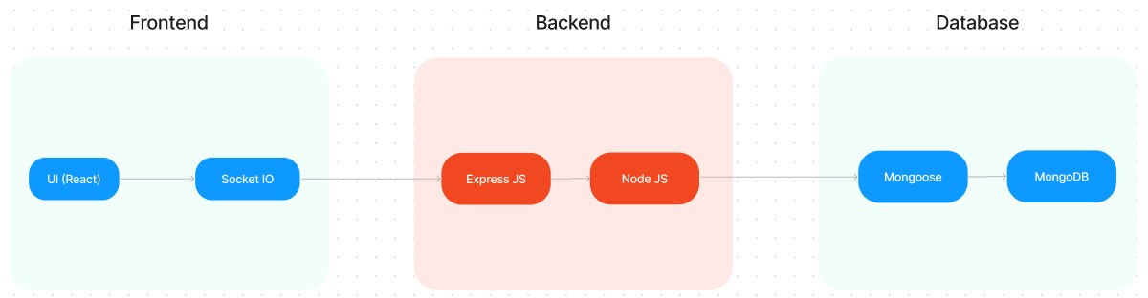

**Communication & Collaboration:** "Sugar Rush" selects Sarah's proposal based on her impressive portfolio and competitive pricing. SB Works facilitates seamless communication between Sarah and the bakery, allowing them to discuss project specifics and refine the design direction through an integrated chat system.

**Delivery & Feedback:** Once finalized, Sarah submits her logo design through the SB Works platform. "Sugar Rush" can review the design, provide feedback, and request minor revisions if needed. SB Works fosters a collaborative environment where both parties can work towards achieving the desired outcome.

**Building a Thriving Career:** Following a successfulproject completionand a glowing review from "Sugar Rush," Sarah's profile on SB Works gains traction. The positive experience encourages her to actively seek new projects on the platform. With a growing portfolio and strong client testimonials, Sarah is well on her way to establishing a thriving freelance career on SB Works.

**TECHNICAL ARCHITECTURE**

The technicalarchitecture of SBWorks follows a client-server model, where the frontend serves as the client and the backend acts as the server. The frontend encompasses the user interface, presentation, and integratesthe Axios libraryto facilitate easycommunicationwiththe backend through RESTful APIs.

To enhance the user experience, the frontend leverages the Bootstrap and MaterialUI libraries, creating a real-time and visually appealing interface for users.

On the backend, we utilize the Express Js framework to manage server-side logic and communication. Express Js provides a robust foundation for handling requests and responses efficiently.

For data storage and retrieval, SB Works relies on MongoDB. MongoDB offers a scalable and efficient solution for storing various data, including user-contributed locations and images. This ensures quick and reliable access to the information needed to enrich the local tourism experience.

In conjunction, the frontend and backend components, complemented by Express Js, and MongoDB, together form a comprehensive technical architecture for SB Works. This architecture facilitates real-time communication, efficient data exchange, and seamless

integration, ensuring a smooth and immersive experience for users contributing to and exploring their local surroundings.

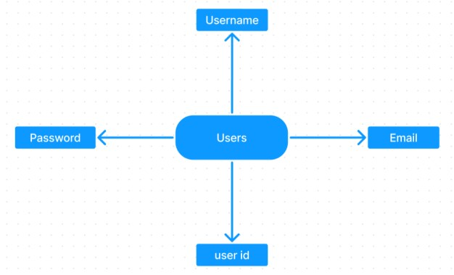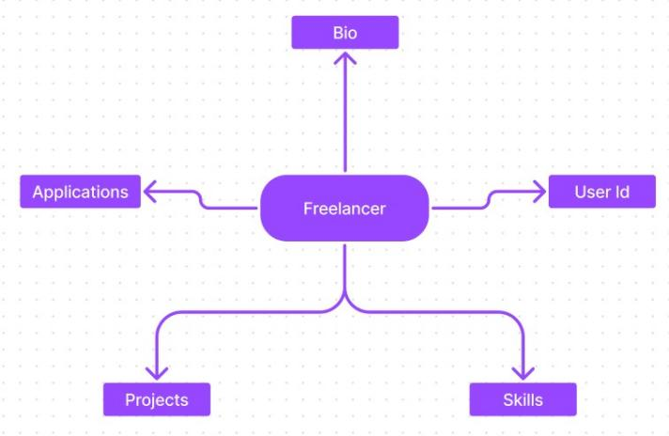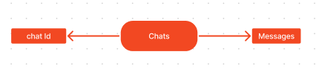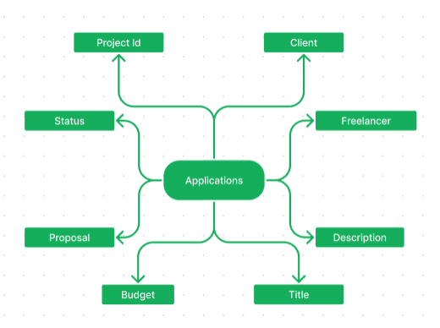**ER DIAGRAM**

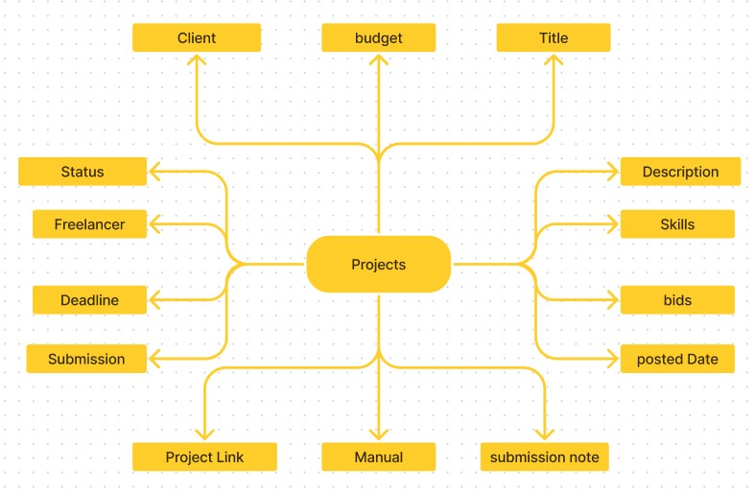

SB Works connects clients with skilled freelancers through a user-friendly platform. Clients

can post projects with details and browse freelancer profiles to find the perfect match.

Freelancers can submit proposals, collaborate with clients through secure chat, and securely

submit work for review and payment. An admin team ensures quality and communication,

making SB Works a go-to platform for both clients and freelancers.

**PROJECT STRUCTURE**

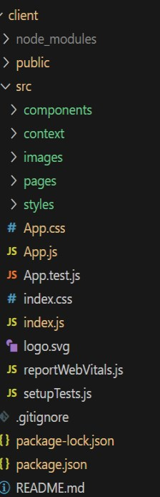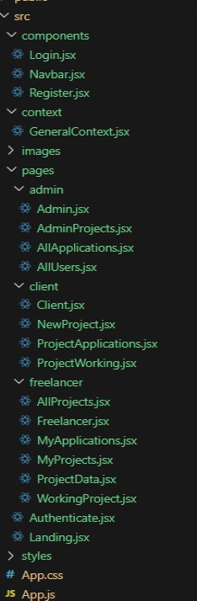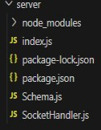

SB Works leverages React.js for the user interface. The client-side code likely consists of reusable components for profiles, projects, and chat, assembled into pages like project browsing or freelancer profiles. Shared data likeuser info or search filters might be managed with React Context. On theserver side, Node.js handles API requests for user management, project actions, and communication. Mongoose models ensure structured interaction with the MongoDB database. This breakdown provides a foundational understanding of SB Works' architecture.

**PRE-REQUISTIC:**

Here are the key prerequisites for developing a full-stack application using Express Js, MongoDB, React.js:

✓**Node.js and npm:**

Node.js is a powerful JavaScript runtime environment that allows you to run JavaScript code on the server-side. It provides a scalable and efficient platform for building network applications. Install Node.js and npm on your development machine, as they are required to run JavaScript on the server-side.

Download: https://nodejs.org/en/download/

Installation instructions: <https://nodejs.org/en/download/package-manager/>

✔**Express.js:**

Express.js is a fast and minimalist web application framework for Node.js. It simplifies the process of creating robust APIs and web applications, offering features like routing, middleware support, and modular architecture.

Install Express.js, a web application framework for Node.js, which handles server-side routing, middleware, and API development.

Installation: Open your command prompt or terminal and run the following command:

**npm install express**

✔**MongoDB:**

MongoDB is a flexible and scalable NoSQL database that stores data in a JSON-like format. It provides high performance, horizontal scalability, and seamless integration with Node.js, making it ideal for handling large amounts of structured and unstructured data.

Set up a MongoDB database to store your application's data. Download: https://www.mongodb.com/try/download/community

Installation instructions: <https://docs.mongodb.com/manual/installation/>

✔**React.js:**

React.js is a popular JavaScript library for building user interfaces. It enables developers to create interactive and reusable UI components, making it easier to build dynamic and responsive web applications.

Install React.js, a JavaScript library for building user interfaces.

Follow the installation guide: <https://reactjs.org/docs/create-a-new-react-app.html>

✔**HTML, CSS, and JavaScript**: Basic knowledge of HTML for creating the structure of your app, CSS for styling, and JavaScript for client-side interactivity is essential.

✔**Database Connectivity**: Use a MongoDB driver or an Object-Document Mapping (ODM) library like Mongoose to connect your Express Js server with the MongoDB database and perform CRUD (Create, Read, Update, Delete) operations

✔**Front-end Framework**: Utilize React Js to build the user-facing part of the application, including entering booking room, status of the booking, and user interfaces for the admin dashboard. For making better UI we have also used some libraries like material UI and bootstrap.

✔**Version Control**: Use Git for version control, enabling collaboration and tracking changes throughout the development process. Platforms like GitHub or Bitbucket can host your repository. Git: Download and installation instructions can be found at: https://git-scm.com/downloads

✔**Development Environment**: Choose a code editor or Integrated Development Environment (IDE) that suits your preferences, such as Visual Studio Code, Sublime Text, or WebStorm.

• Visual Studio Code: Download from <https://code.visualstudio.com/download>

To run the existing Freelancer App project downloaded from Drive: Use the code:

Drive link: <https://drive.google.com/drive/folders/10mSn2lMTaVMDWWFNjeJjiOLfmcD3-87C?usp=sharing>

Install Dependencies:

• Navigate into the cloned repository directory: cd freelancer-app-MERN

• Install the required dependencies by running the following commands:

cd client npm install ../cd server npm install

Start the Development Server:

• To start the development server, execute the following command: npm start

• The SB Works app will be accessible at [http://localhost:3000](http://localhost:3000/)

You have successfully installed and set up the SB Works application on your local machine. You can now proceed with further customization, development, and testing as needed.

**Application flow:**

**Freelancer Responsibilities:**

• Project Submission: Freelancers are responsible for submitting completed and high-quality work for the assigned projects through the platform.

• Compliance: Ensure that the submitted work adheres to client requirements, industry standards, and any specific guidelines outlined by the platform.

• Effective Communication: Actively engage in communication with clients, promptly responding to messages, asking clarifying questions, and providing updates on the project progress.

• Time Management: Manage time effectively to meet project deadlines and deliver work in a timely manner.

• Professionalism: Conduct oneself professionally by maintaining a respectful and cooperative attitude with clients and fellow freelancers.

• Quality Assurance: Deliver work that is accurate, well-executed, and free from errors to maintain client satisfaction.

**Client Responsibilities:**

• Clear Project Description: Provide a detailed and comprehensive project description, including deliverables, desired outcomes, and any specific requirements.

• Timely Communication: Respond promptly to freelancer inquiries, providing necessary information and feedback in a timely manner.

• Payment Obligations: Fulfill the agreed-upon payment terms promptly and fairly upon satisfactory completion of the project.

• Feedback and Evaluation: Provide constructive feedback and evaluate the freelancer's performance, helping them improve and providing valuable insights.

**Admin Responsibilities:**

• Data Oversight: As an admin, one of your key responsibilities is to monitor and ensure the integrity and security of all data on the platform

• Policy Enforcement: Admins play a crucial role in enforcing platform policies, guidelines, and ethical standards.

• Conflict Resolution: In the event of disputes or issues within the community, it is the admin's responsibility to address them promptly and impartially

• User Support and Communication: Admins should provide support and guidance to users on the platform

• Platform Maintenance and Improvement: Admins are responsible for the overall maintenance and improvement of the research platform.

**Project Flow:**

Use the code in**:** <https://drive.google.com/drive/folders/10mSn2lMTaVMDWWFNjeJjiOLfmcD3-87C?usp=sharing>

Demo video: <https://drive.google.com/file/d/1erdcudF8D00QyHEf0aMKioTAqWa2AjDb/view?usp=sharing>

**Milestone 1: Project setup and configuration.** ✓**Folder setup:**

Now, firstlycreate the folders for frontend and backend to writethe respective code and install the essential libraries.

• Client folders.

• Server folders

✓**Installation of required tools:**

1. Open the frontend folder to install necessary tools For frontend, we use:

▪ React

▪ Bootstrap

▪ Material UI ▪ Axios

▪ react-bootstrap

2. Open the backend folder to install necessary tools

For backend, we use: ▪ Express Js

▪ Node JS

▪ MongoDB ▪ Mongoose ▪ Cors

▪ Bcrypt

After the installation of all the libraries, the package.json files for the frontend looks like the one mentioned below.

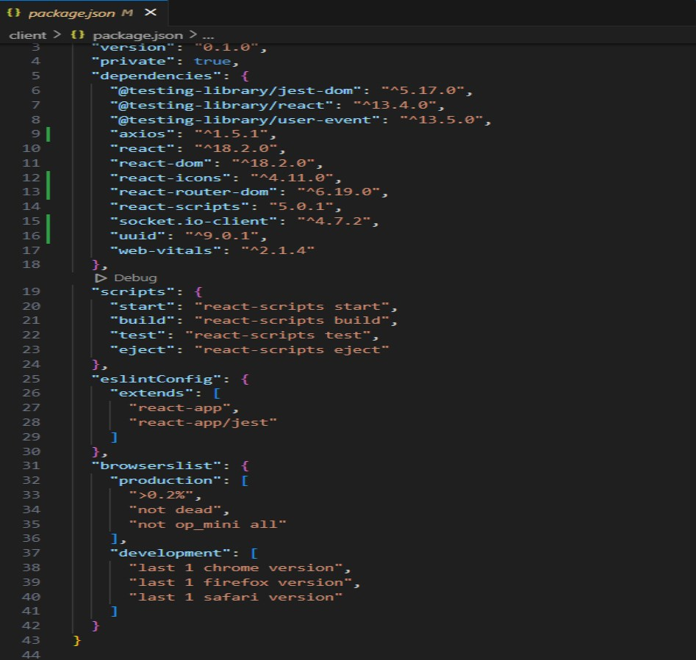

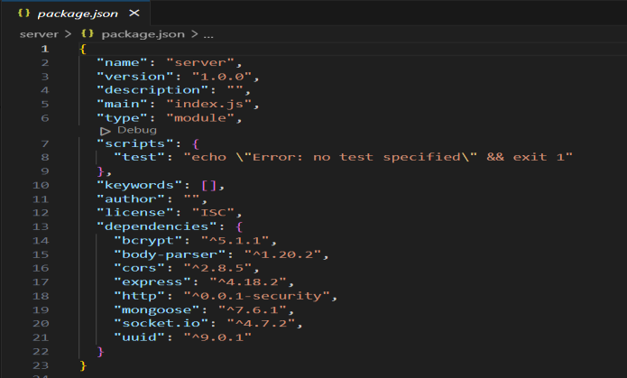After the installation of all the libraries, the package.json files for the backend looks like the one mentioned below.

**Milestone 2: Backend Development**

**1. Project Setup:**

• Create a project directory and initialize it using npm init.

• Install required dependencies like Express.js, Mongoose, body-parser, and cors. **2. Database Configuration:**

• Set up a MongoDB database (locally or using a cloud service like MongoDB Atlas).

• Create collections for:

• Users (storing user information, account type)

• Projects (project details, budget, skills required)

• Applications (freelancer proposals, rate, portfolio link) • Chat (communication history for each project)

• Freelancer (extended user details with skills, experience, ratings)

**3. Express.js Server:**

• Create an Express.js server to handle HTTP requests and API endpoints.

• Configure body-parser to parse request bodies and cors for cross-origin requests.

**4. API Routes:**

• Define separate route files for user management, project listing, application handling, chat functionality, and freelancer profiles.

• Implement route handlers using Express.js to interact with the database: • User routes: registration, login, profile management.

• Project routes: project creation, listing, details retrieval. • Application routes: submit proposals, view applications. • Chat routes: send and receive messages within projects.

• Freelancer routes: view and update profiles, showcase skills.

**5. Data Models:**

• Define Mongoose schemas for each data entity: • User schema

• Project schema

• Application schema • Chat schema

• Freelancer schema (extends User schema with skills, experience) • Create Mongoose models to interact with the MongoDB database. • Implement CRUD operations for each model to manage data.

**6. UserAuthentication:**

• Implement user authentication using JWT or session-based methods. • Create routes and middleware for user registration, login, and logout.

• Use authentication middleware to protect routes requiring user authorization (e.g., applying for projects).

**7. Project Management:**

• Allow clients to post projects with details and budget.

• Enable freelancers to browse projects, search by skills, and submit proposals. • Implement a system for clients to review applications and choose freelancers.

**8. Secure Communication & Collaboration:**

• Integrate a secure chat system within projects for communication between clients and freelancers.

• Allow file attachments and feedback exchange to facilitate collaboration.

**9. Admin Panel (Optional):**

• Implement an admin panel with functionalities like: • Managing users

• Monitoring project updates and applications • Accessing transaction history

Reference video: [https://drive.google.com/file/d/1zrOMSp6svjH1tRcul3b442XVPNyKTSp4/view?usp=sharin](https://drive.google.com/file/d/1zrOMSp6svjH1tRcul3b442XVPNyKTSp4/view?usp=sharing) [g](https://drive.google.com/file/d/1zrOMSp6svjH1tRcul3b442XVPNyKTSp4/view?usp=sharing)

**Milestone 3: Database development**

o Set up a MongoDB database either locally or using a cloud-based MongoDB service like MongoDB Atlas.

o Create a database and define the necessary collections for users, freelancer, projects, chats, and applications.

o Connect the database to the server with the code provided below.

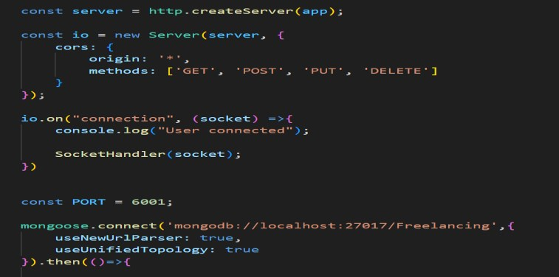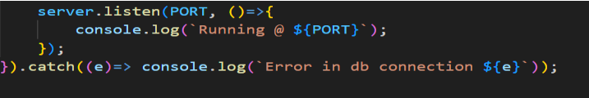

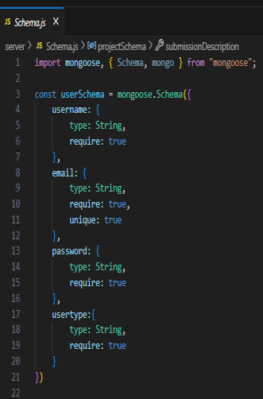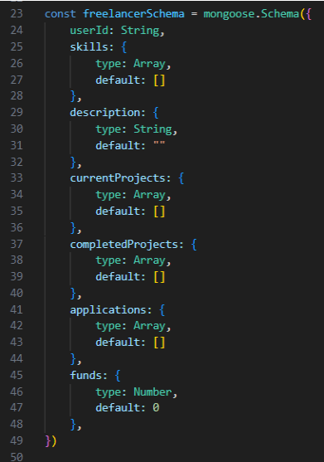The Schemas for the database are given below

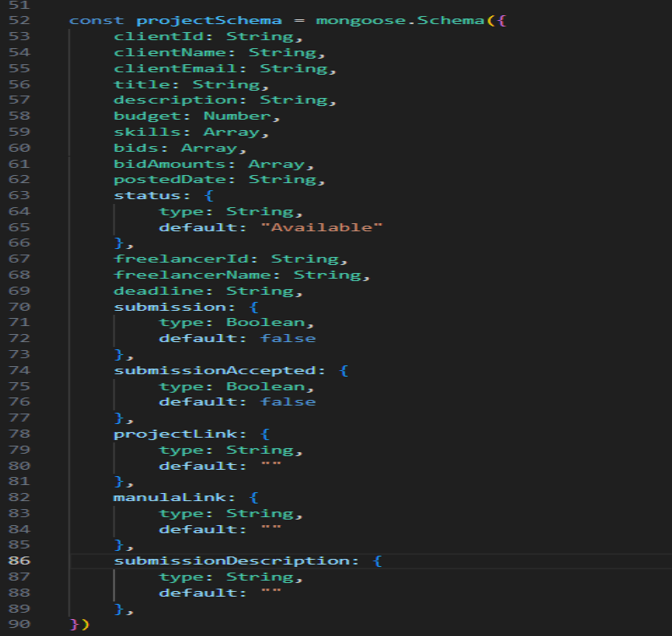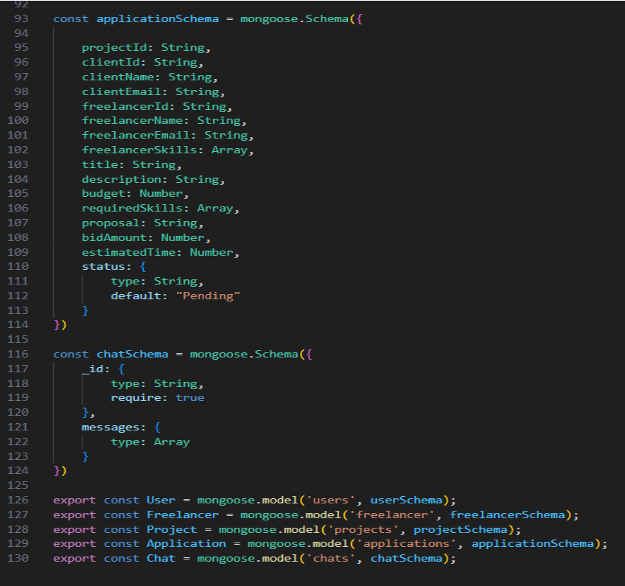

**Milestone 4: Frontend development**

**1. Setting the Stage:**

The SB Works frontend thrives on React.js. To get started, we'll:

• Create the initial React application structure.

• Install essential libraries for enhanced functionality.

• Organize project files for a smooth development experience.

• This solid foundation ensures an efficient workflow as we bring the SB Works interface to life.

**2. Crafting the User Experience:**

Next, we'll focus on the user interface (UI). This involves:

• Designing reusable UI components like buttons, forms, and project cards.

• Defining the layout and styling for a visuallyappealing and consistent interface. • Implementing navigation elements for intuitive movement between features.

• These steps will create a user-friendly experience for both freelancers and clients.

**3. Bridging the Gap:**

The final stage connects the visual interface with the backend data. We'll:

• Integrate the frontend with SB Works' API endpoints.

• Implement data binding to ensure dynamic updates between user interactions and the displayed information.

This completes the frontend development, bringing the SB Works platform to life for users.

Reference video: [https://drive.google.com/file/d/16o7iRxHfaKKHJkep1ixKs86C3nfNACVQ/view?usp](https://drive.google.com/file/d/16o7iRxHfaKKHJkep1ixKs86C3nfNACVQ/view?usp=sharing) [=sharing](https://drive.google.com/file/d/16o7iRxHfaKKHJkep1ixKs86C3nfNACVQ/view?usp=sharing)

**Milestone 5: Project Implementation**

On completing the development part, we then run the application one last time to verify

all the functionalities and look for any bugs in it. The user interface of the application looks a bit like the images provided below.

**Landing page:**

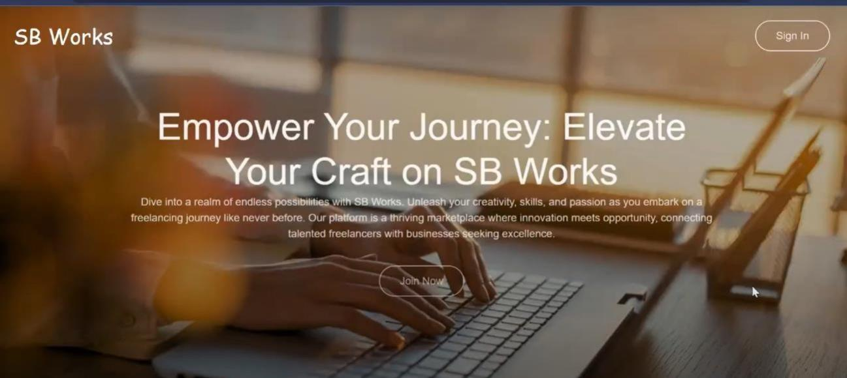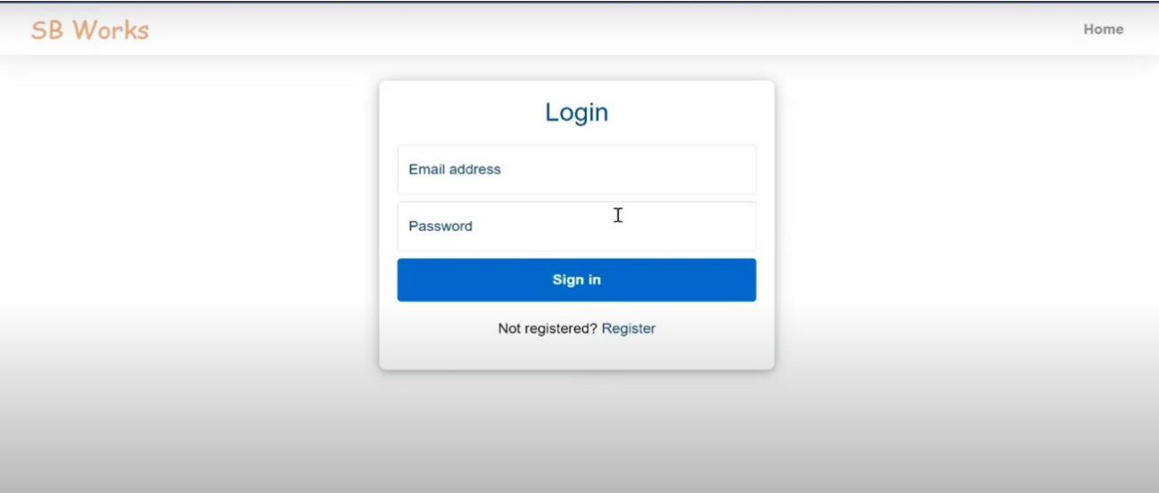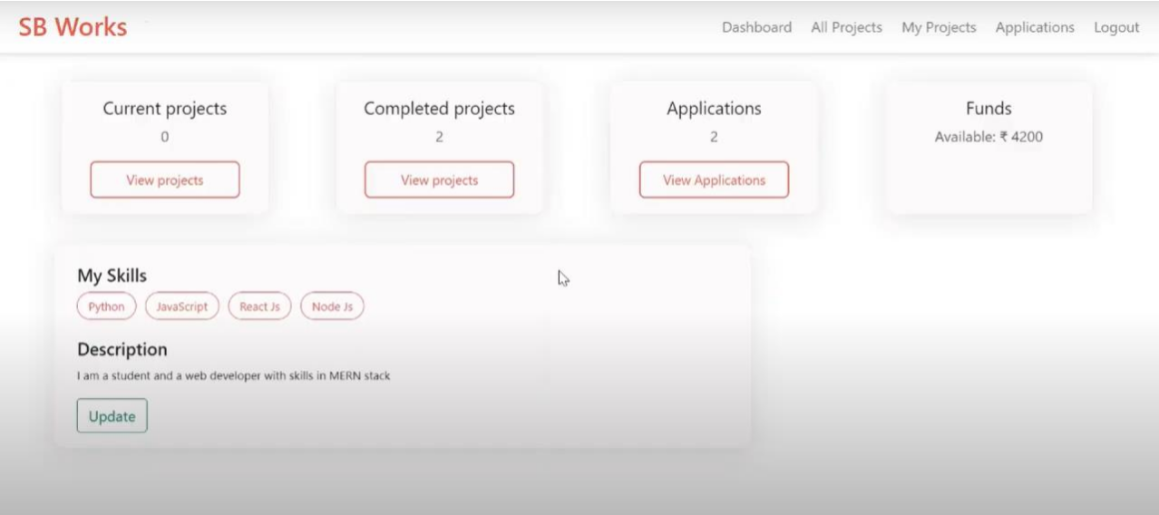

**Authentication:**

**Freelancer dashboard:**

**Admin dashboard:**

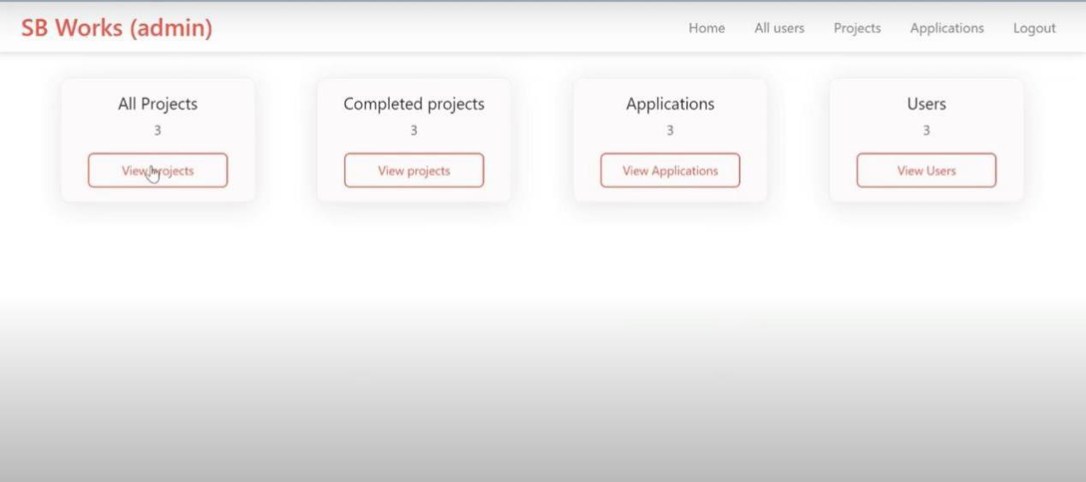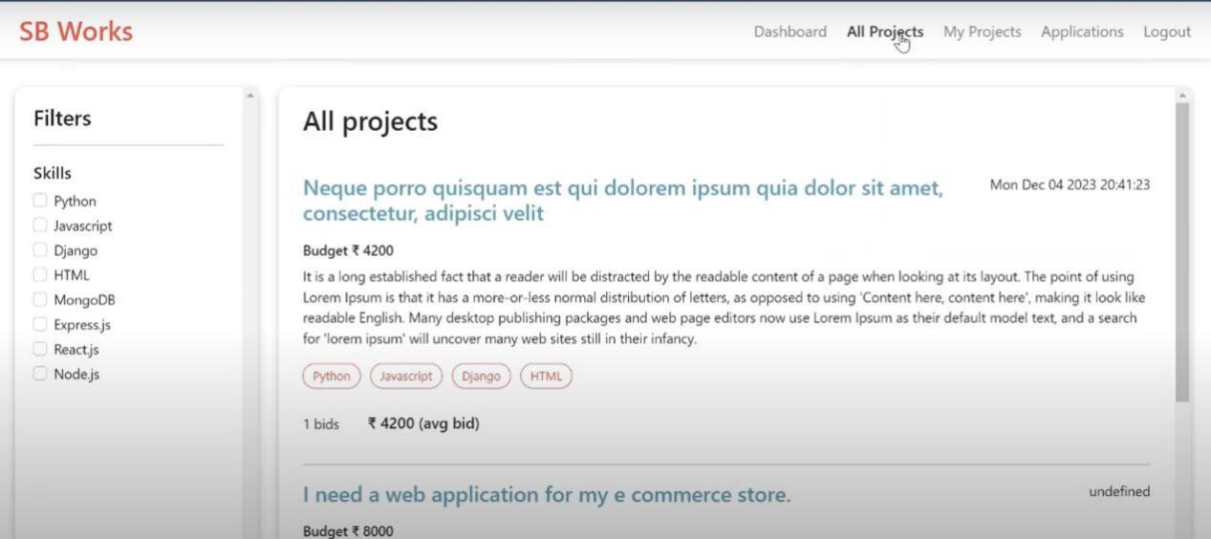

**All projects:**

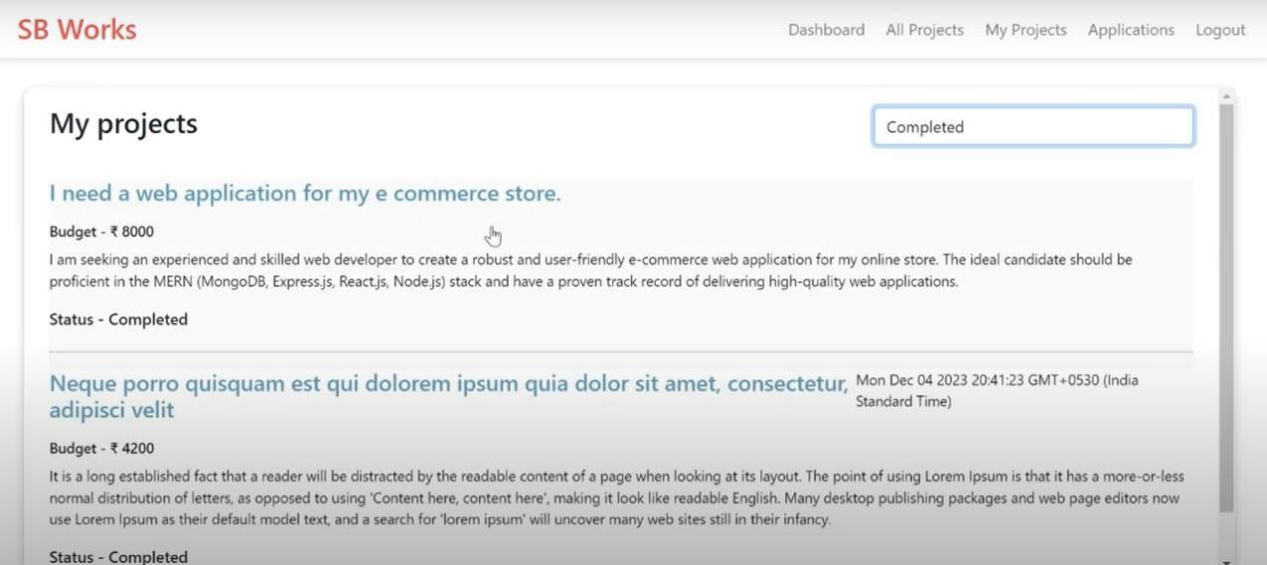**Freelance projects:**

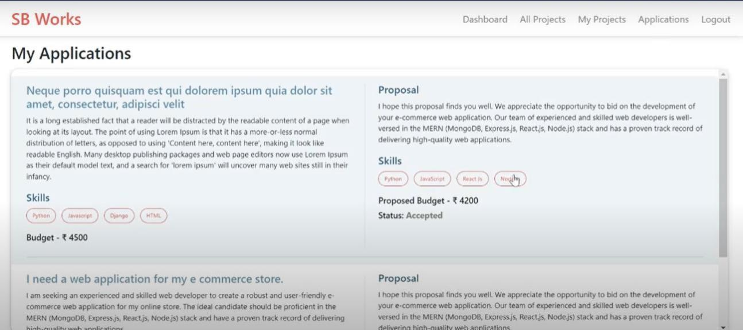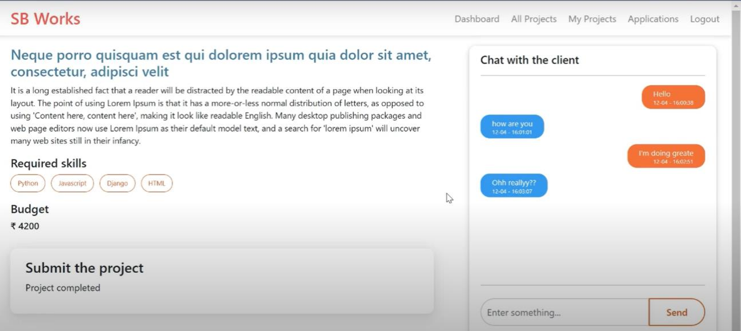

**Applications:**

**Project page:**

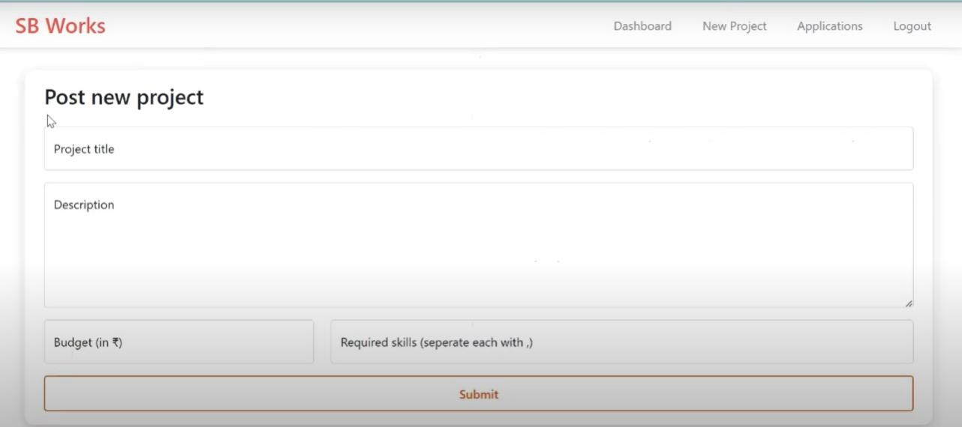**New project:**

For any further doubts or help, please consider the code in the drive link given below,

[https://drive.google.com/drive/folders/10mSn2lMTaVMDWWFNjeJjiOLfmcD3-](https://drive.google.com/drive/folders/10mSn2lMTaVMDWWFNjeJjiOLfmcD3-87C?usp=sharing)

[87C?usp=sharing](https://drive.google.com/drive/folders/10mSn2lMTaVMDWWFNjeJjiOLfmcD3-87C?usp=sharing)

The demo of the app is available at:

<https://drive.google.com/file/d/1erdcudF8D00QyHEf0aMKioTAqWa2AjDb/view?usp=sharing>

**\*\* Happy Coding \*\***